SQL Task 2

1. Create a report showing Northwind's orders sorted by Freight from most expensive to cheapest. Show OrderID, OrderDate, ShippedDate, CustomerID, and Freight.
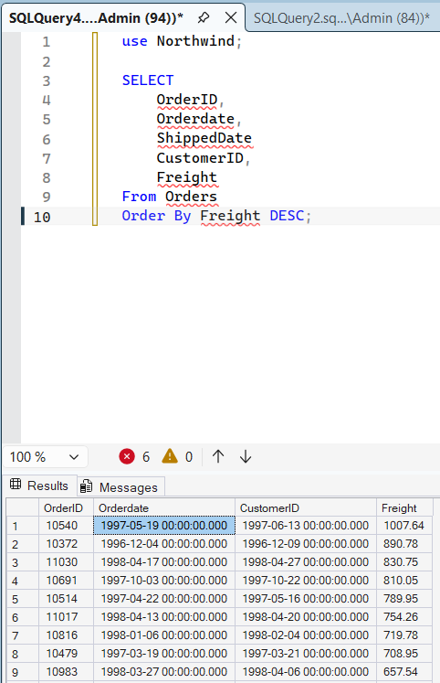

2. Select CompanyName, Fax, Phone, HomePage and Country from the Suppliers table sorted by Country in descending order and then by CompanyName in ascending order.
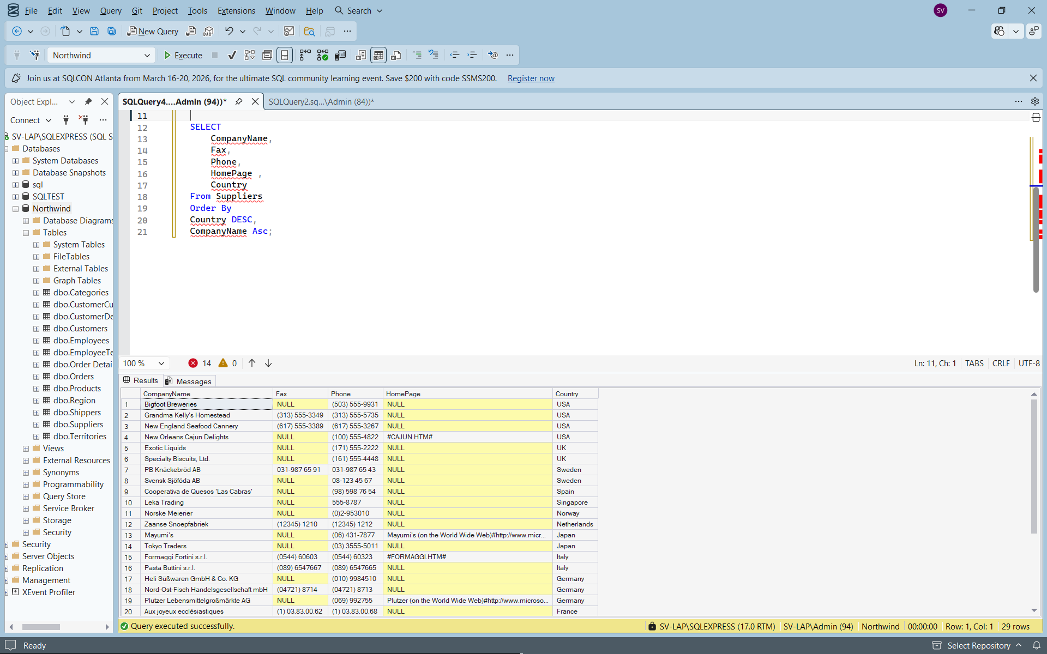

3. Display all the company names and contact names of Northwind's customers inBuenos Aires
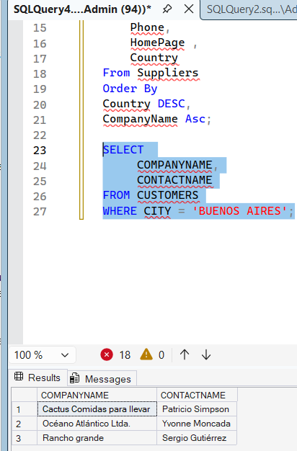

4. Display the product name, unit price and quantity per unit of all products that are out of stock.
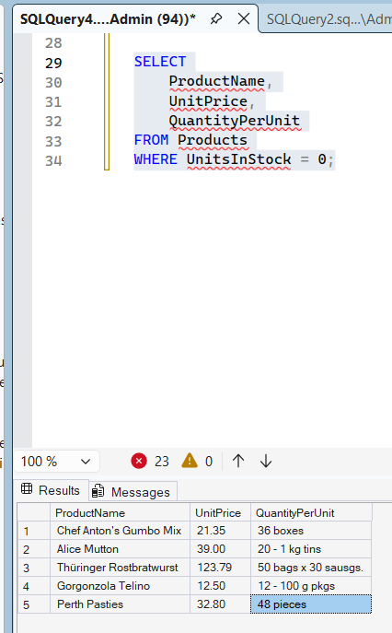

5. Display the order date, shipped date, customer id, and freight of all orders placed on May 19, 1997.
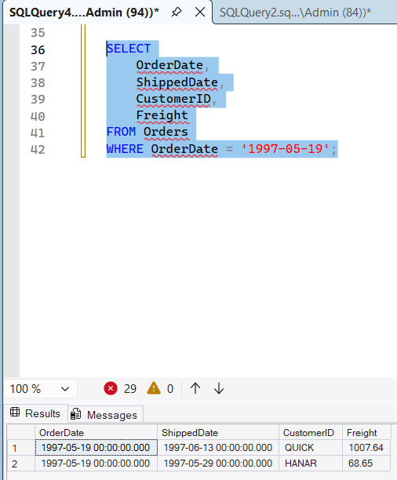

6. Display the first name, last name, and country of all employees not in the United States.
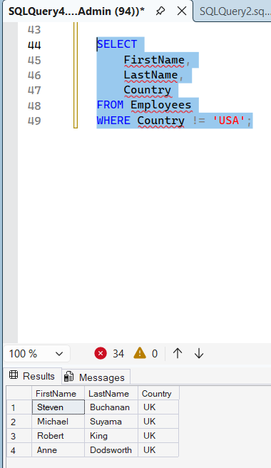
7. Display the employee id, order id, customer id, required date, and shipped date of all orders that were shipped later than they were required.
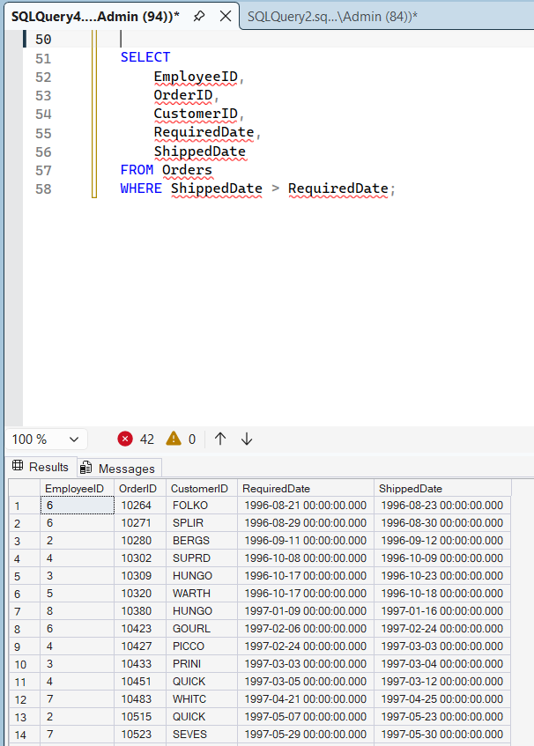

8. Display the city, company name, and contact name of all customers who are in cities that begin with "A" or "B." 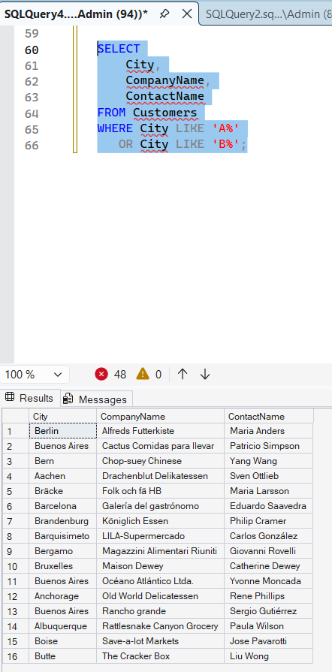

9. Display all orders that have a freight cost of more than $500.00
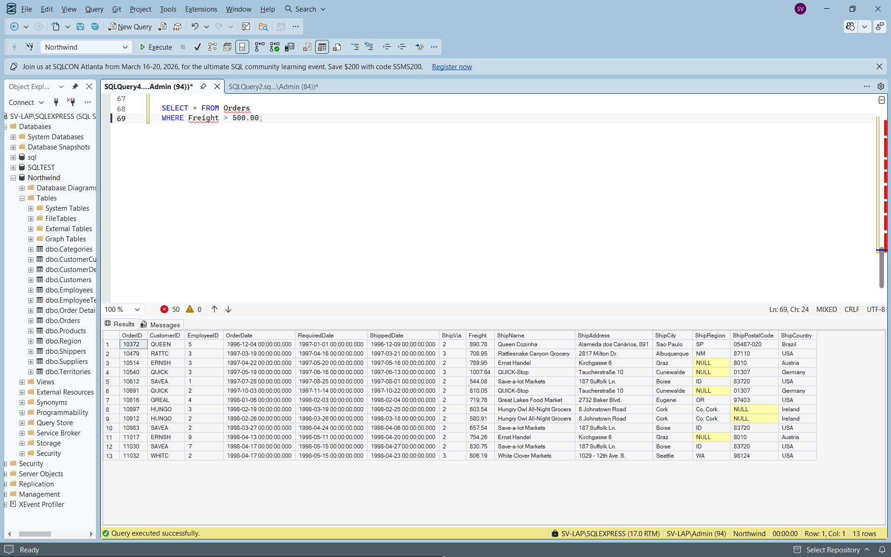

10. Display the product name, units in stock, units on order, and reorder level of all products that are up for reorder
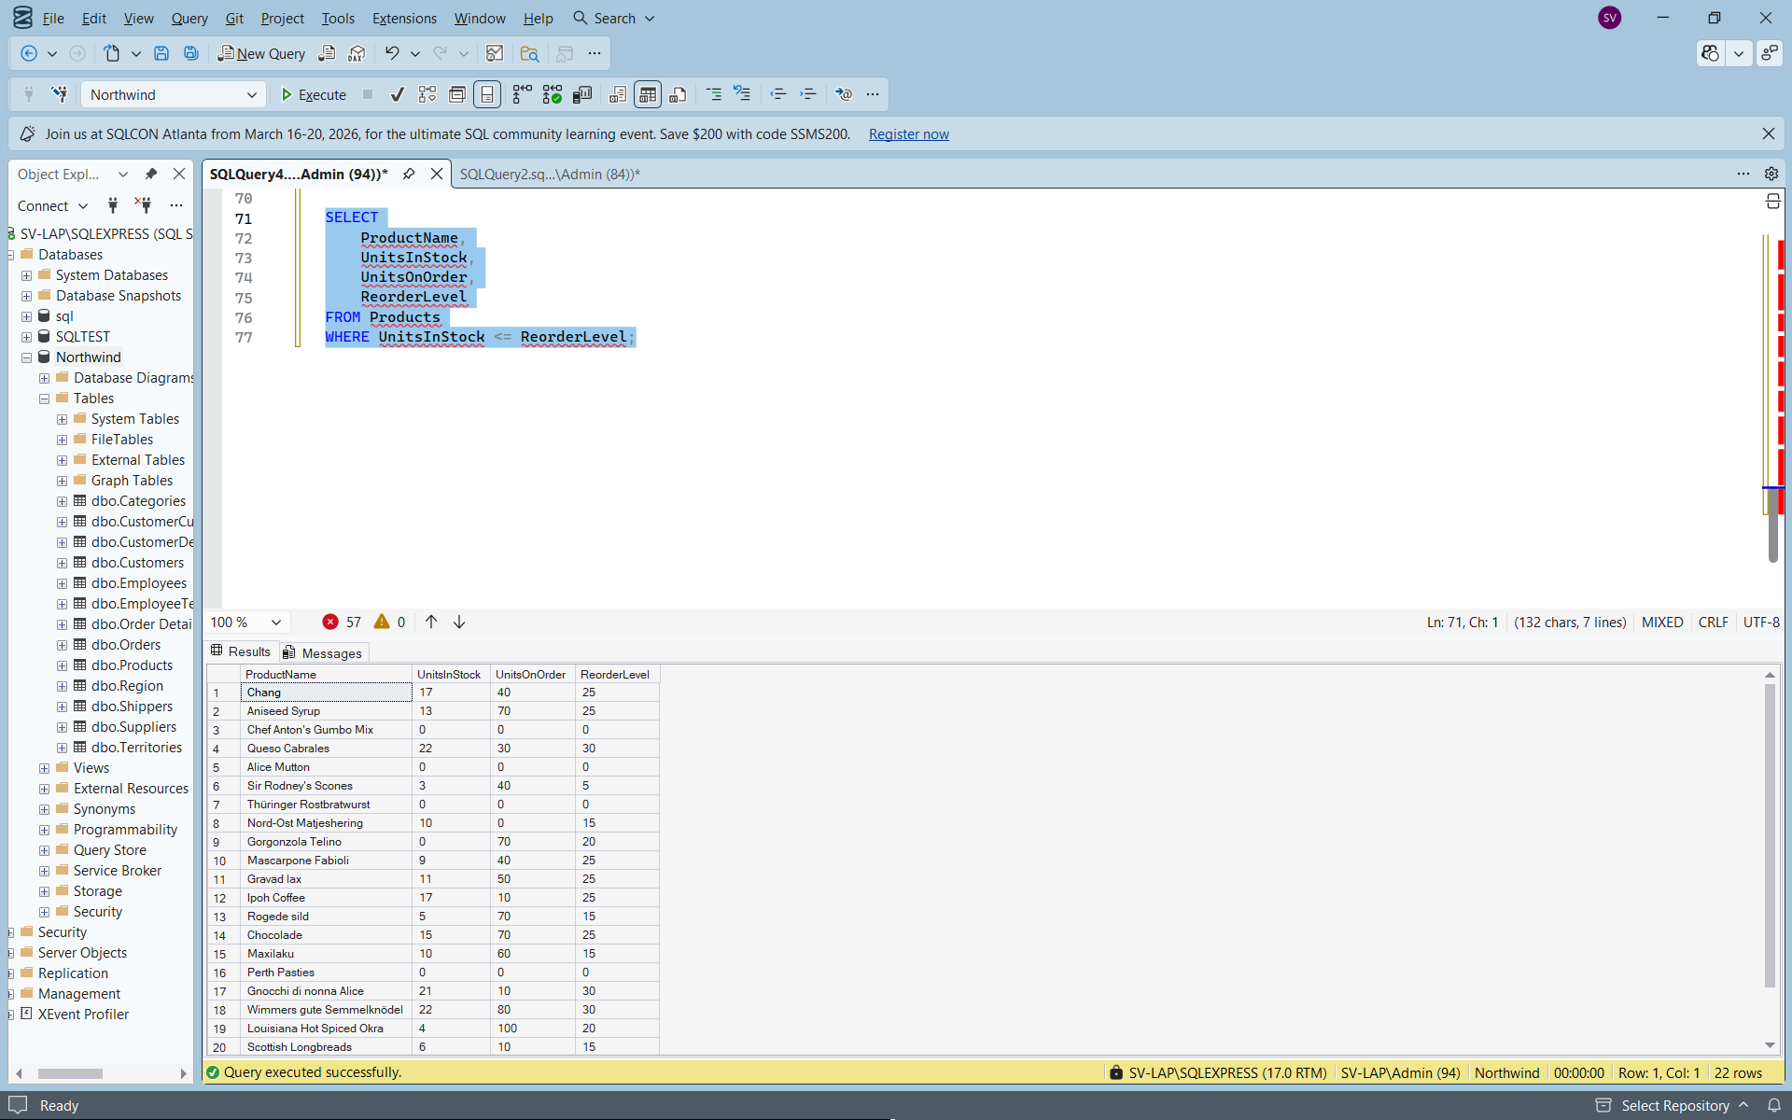

11. Display the company name, contact name and fax number of all customers that have a fax number
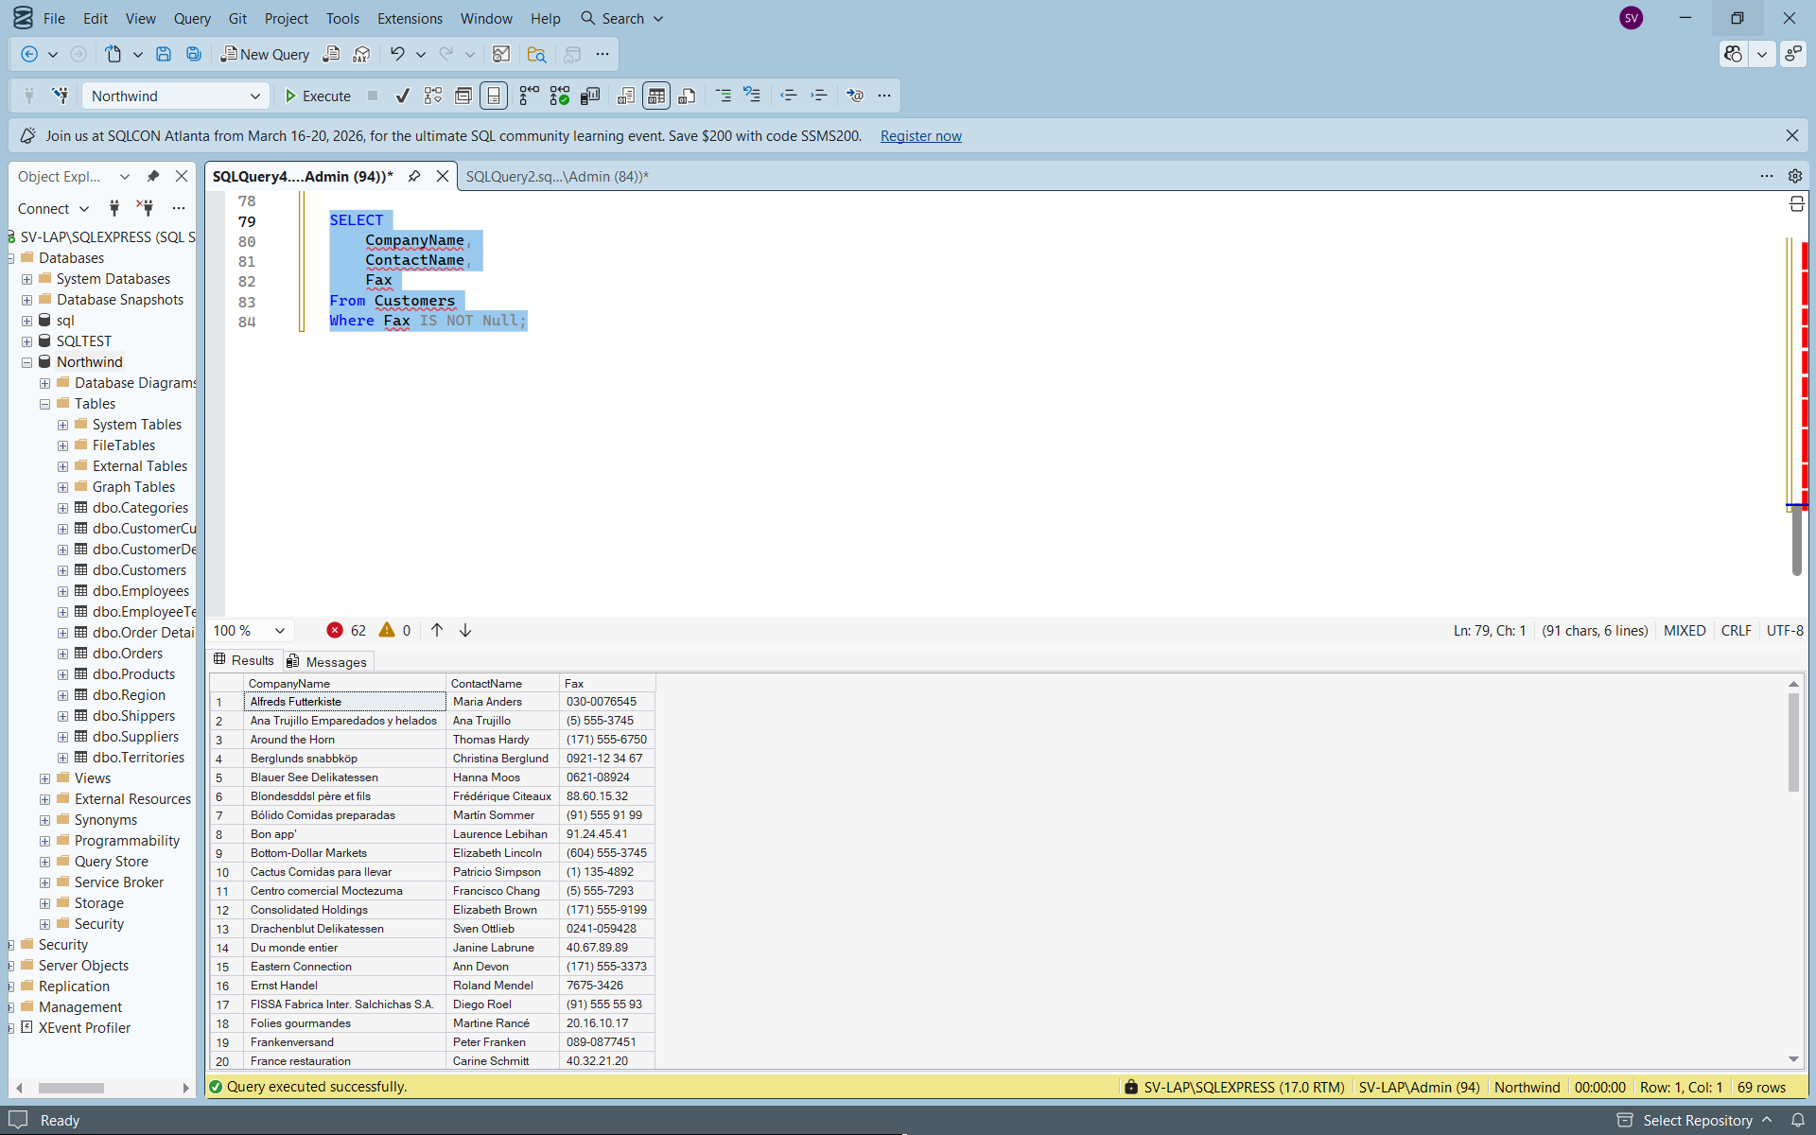
12. Display the first and last name of all employees who do not report to anybody
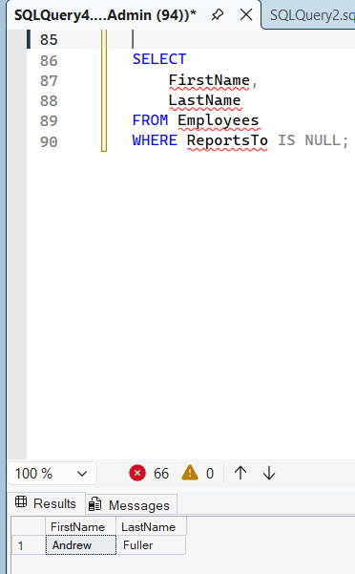
13. Display the company name, contact name and fax number of all customers that have a fax number. Sort by company name.
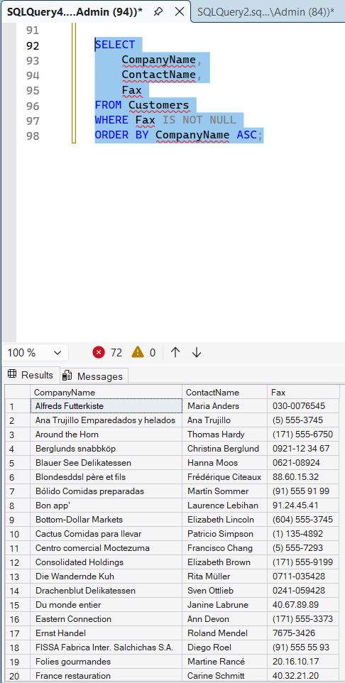
14. Display the city, company name, and contact name of all customers who are in cities that begin with "A" or "B." Sort by contact name in descending order
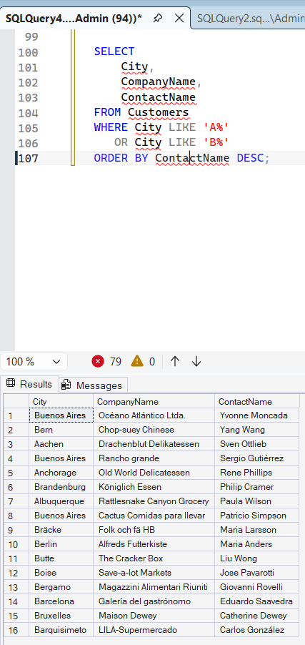
15. Display the first and last names and birth date of all employees born in the 1950s.
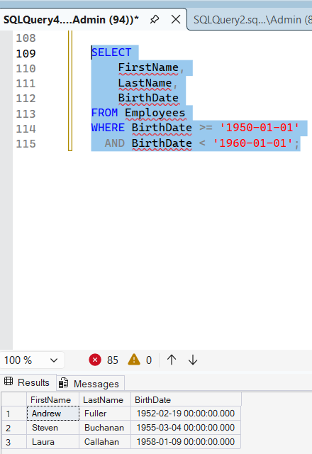
16. Display the product name and supplier id for all products supplied by Exotic Liquids, Grandma Kelly's Homestead, and Tokyo Traders. Hint you will need to first do a separate SELECT on the Suppliers table to find the supplier ids of these three companies.
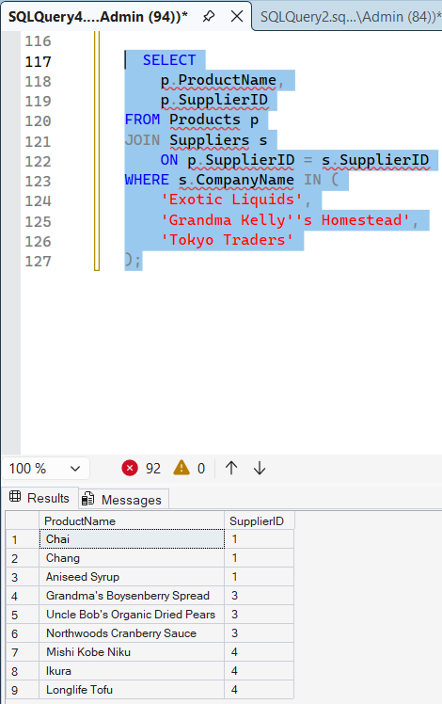
17. Display the shipping postal code, order id, and order date for all orders with a ship postal code beginning with "02389"
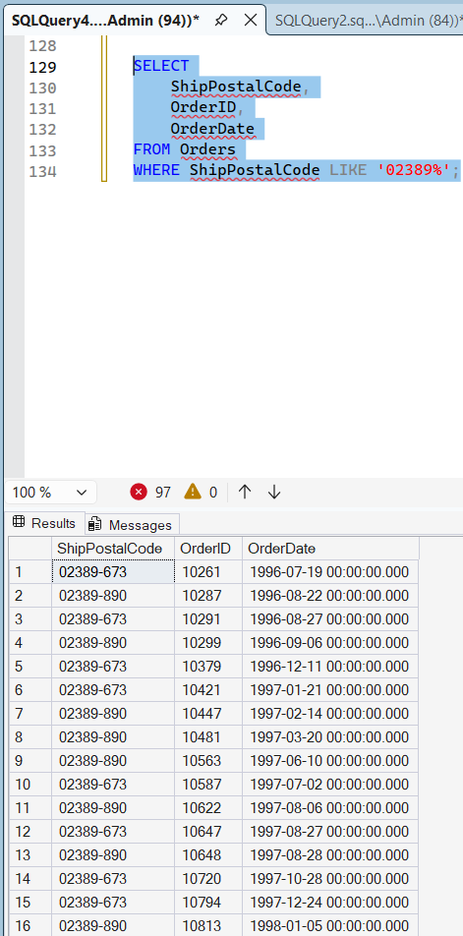
18. Display the contact name and title and the company name for all customers whose contact title does not contain the word "Sales".
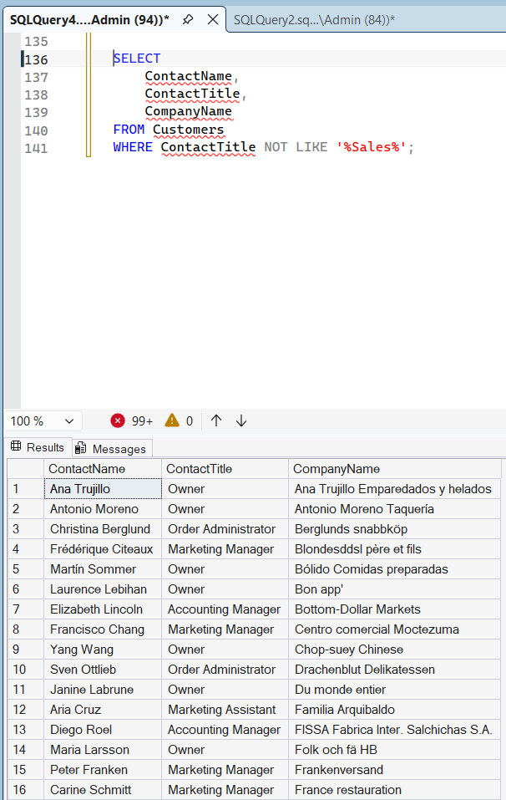
19. Display the company name, contact title, city and country of all customers in Mexico or in any city in Spain except Madrid
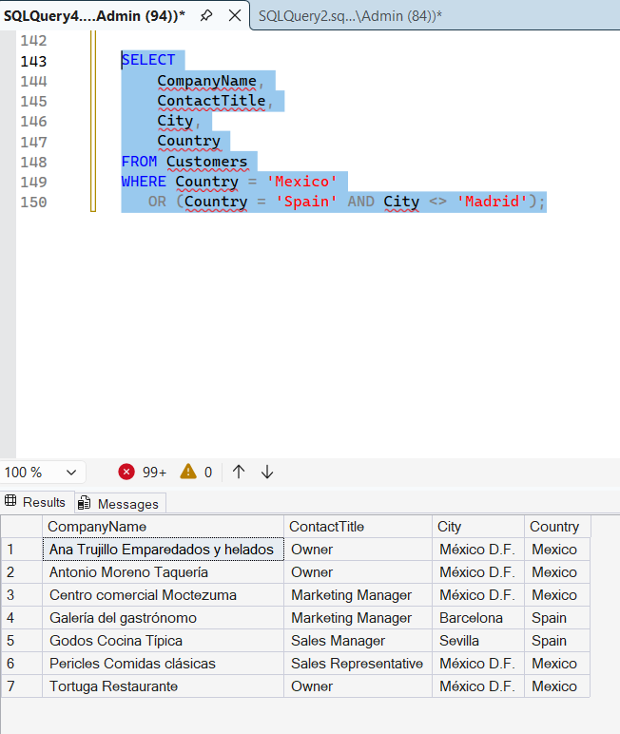

20. Create the following tables with given attributes having appropriate data type and specify the
necessary primary and foreign key constraints:
Customer (Custid. Custname, Age, Phone)
Loan (Loanid. Amount, Custid, EMI)
Account(Acno. Custid, Balance)
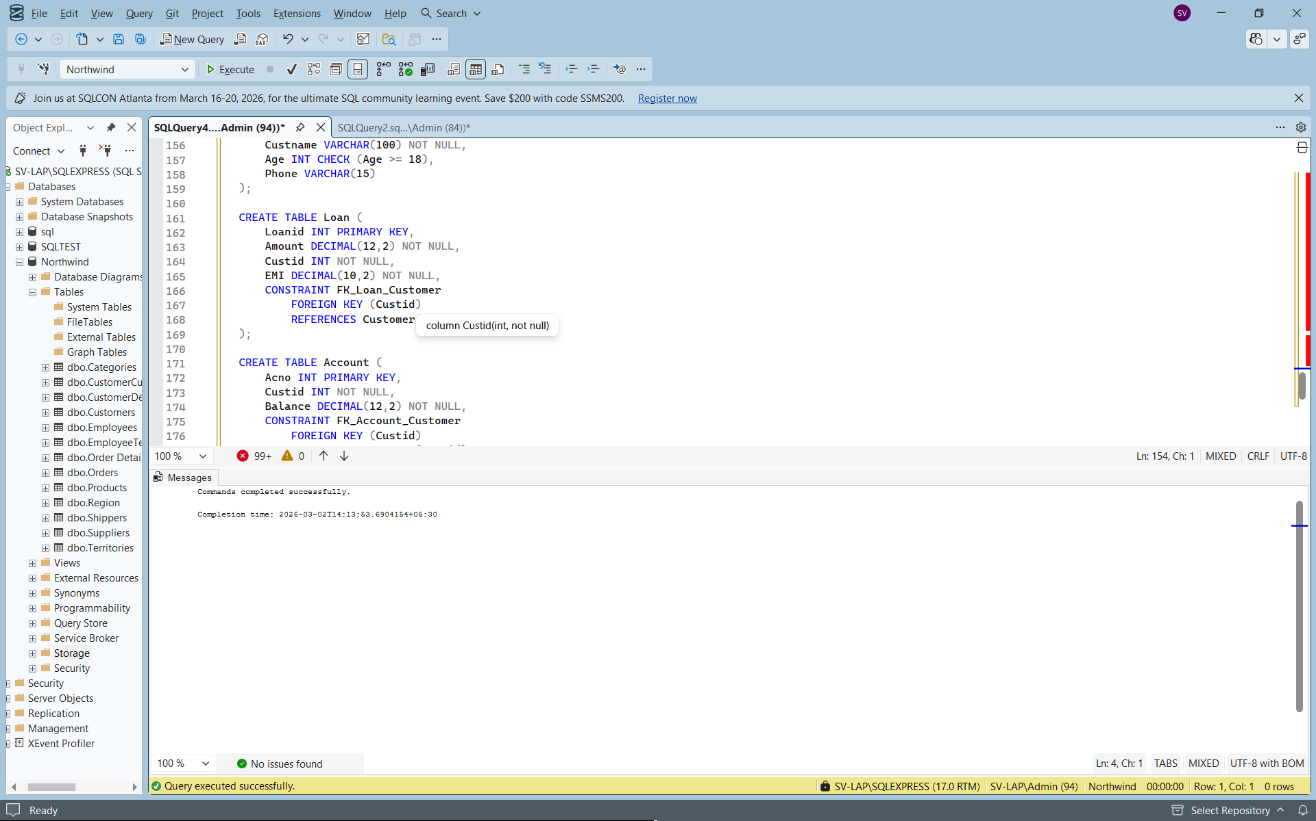
- List the Loanid of Loans with EMI more than Rs.50,000.
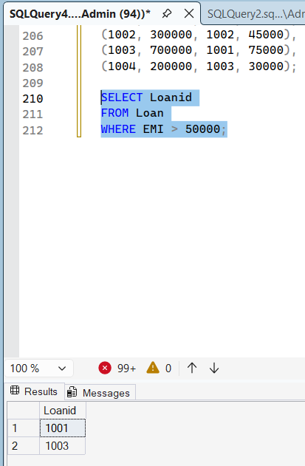
- List the EMI and number of loans with that loan amount.
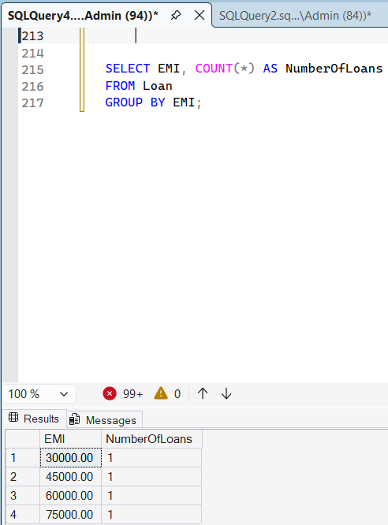
- Create a view to list the total number of loans availed.
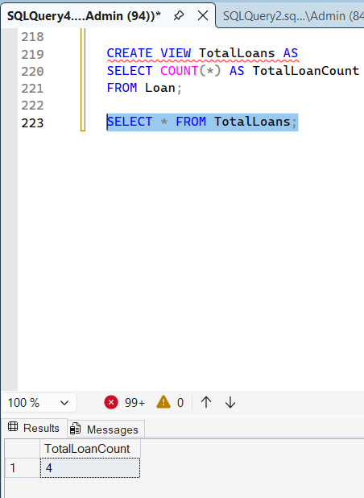
d) Display the EMI amount of Customer "Smith".
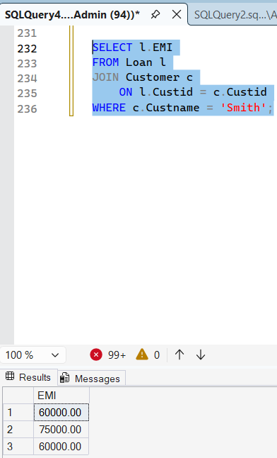
e) Create a procedure to print the
Amount and Custid of Loanid 1001.
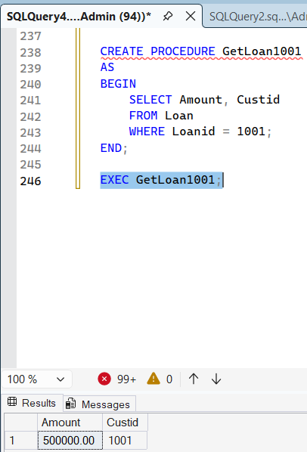
f) Create a function to display the loan amount of customer with customerid 1002.

